TERRAFORM FINAL-CHALLENGE
Create VPC
Open vs code and initialize the terraform and start creating vpc
Syntax:
resource "aws_vpc" "terraform_vpc" {
cidr_block = "10.0.0.0/16"

tags = {
Name = "terraform-vpc"
}
}
After entering the syntax in main.tf file execute terraform init and terraform

Terraform apply and successfully resources were created

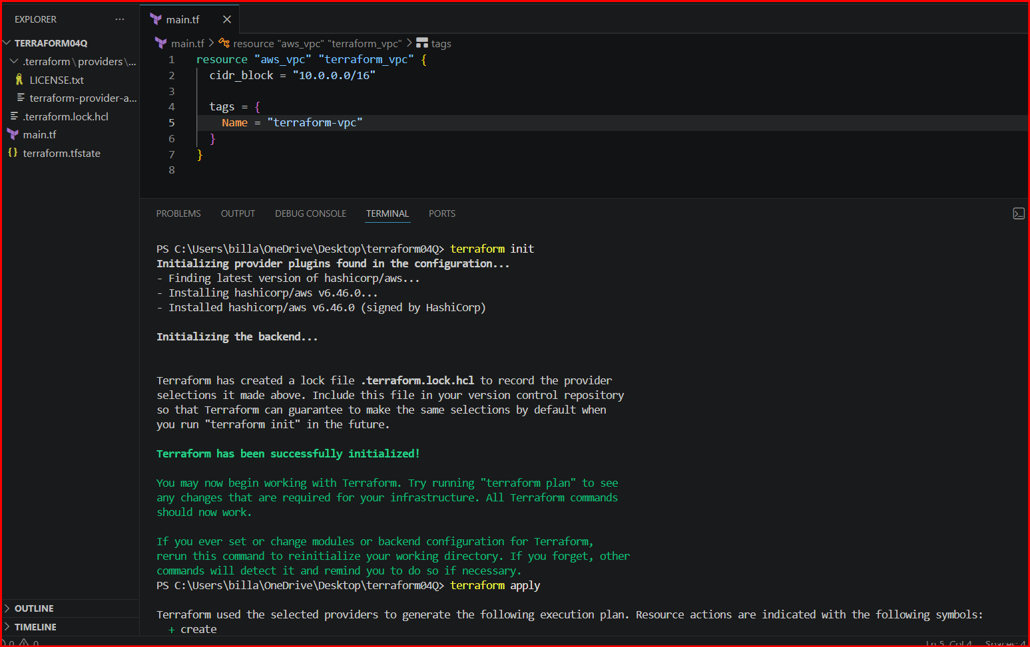
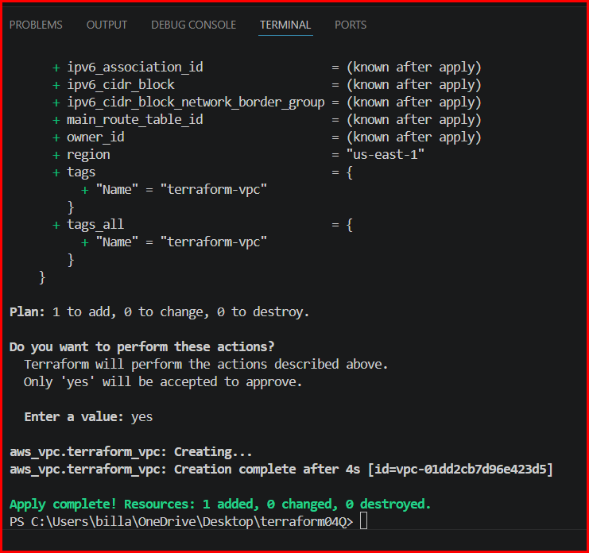

Also verified in portal aws and vpc has been created
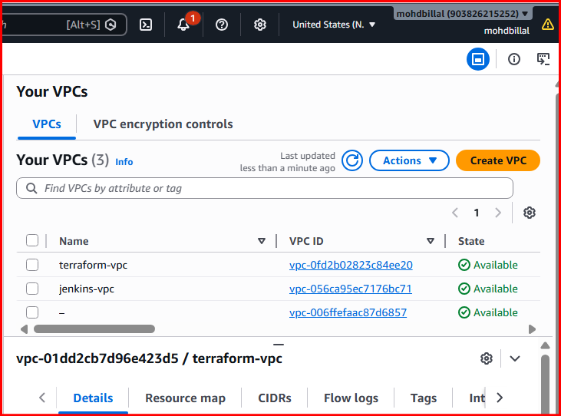
Create Internet gateway:
Created igw for vpc and attach to vpc
Syntax:
resource "aws_internet_gateway" "terraform_igw" {
vpc_id = aws_vpc.terraform_vpc.id

tags = {
Name = "terraform-igw"
}
}
Same execute init and apply commands
Don’t remove old data insert new and execute the actions

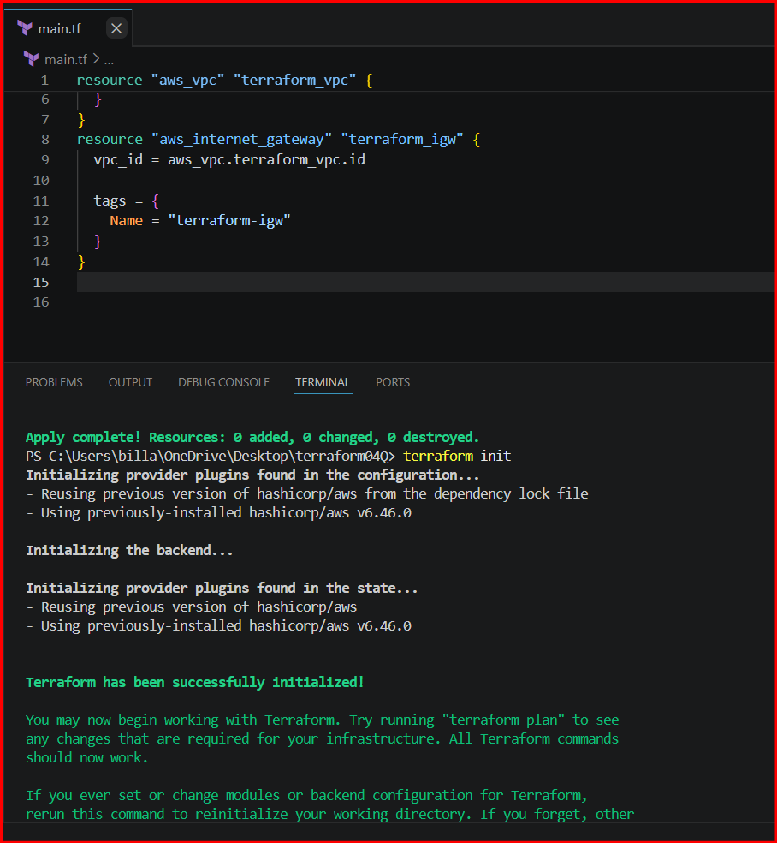

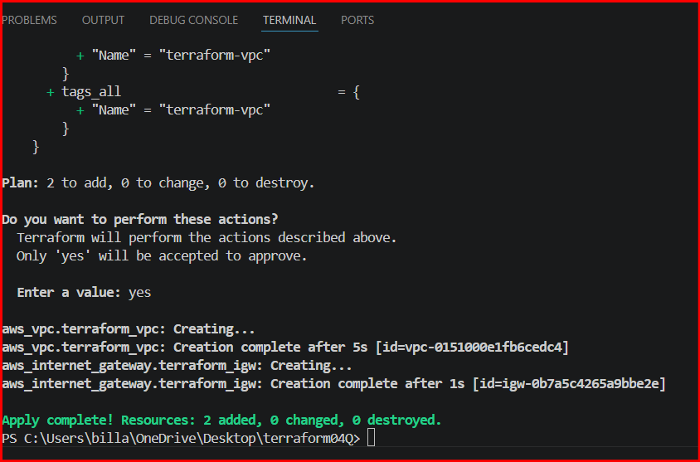
Successfully igw has been created and attached to vpc
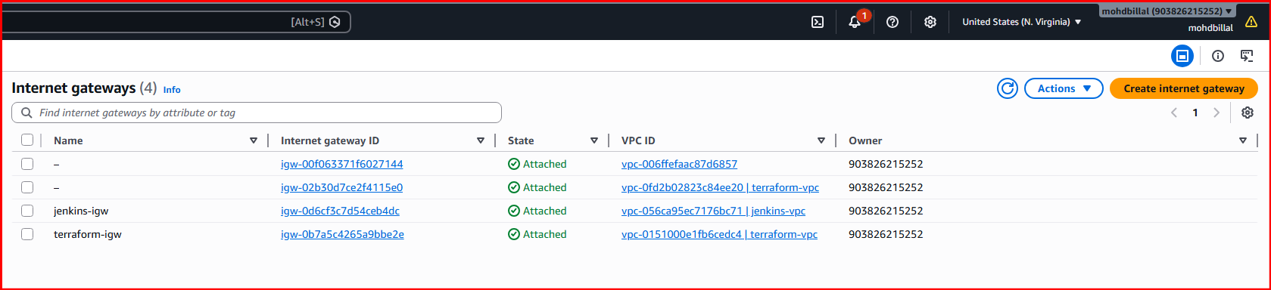



Create Custom Route Table:
Created a route table for vpc
Syntax:
resource "aws_route_table" "terraform_rt" {
vpc_id = aws_vpc.terraform_vpc.id

tags = {
Name = "terraform-rt"
}
}

Terraform init and apply commands

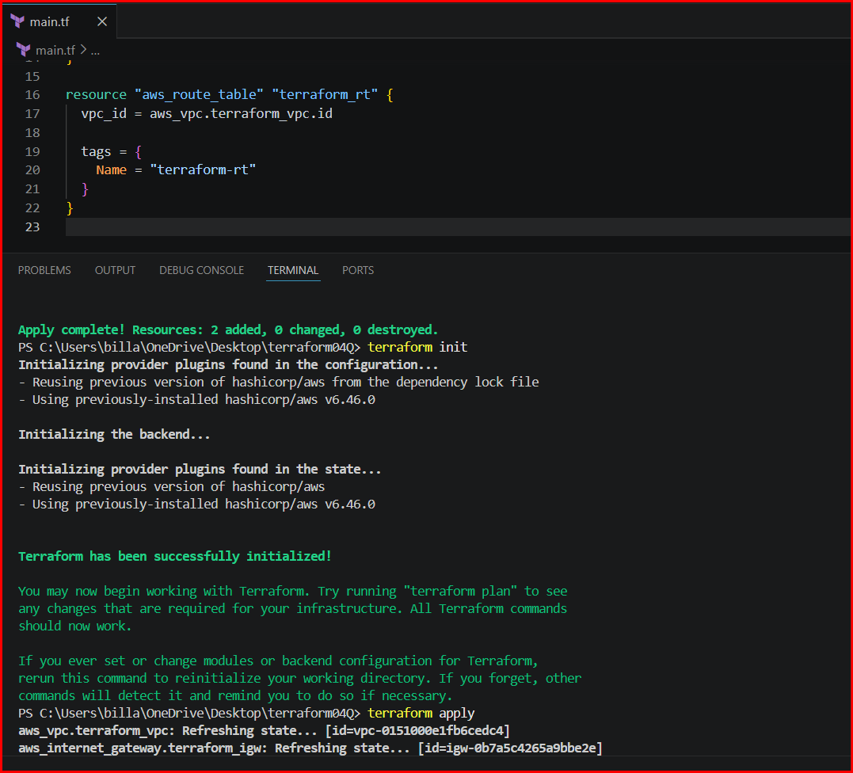
Route tables has been created

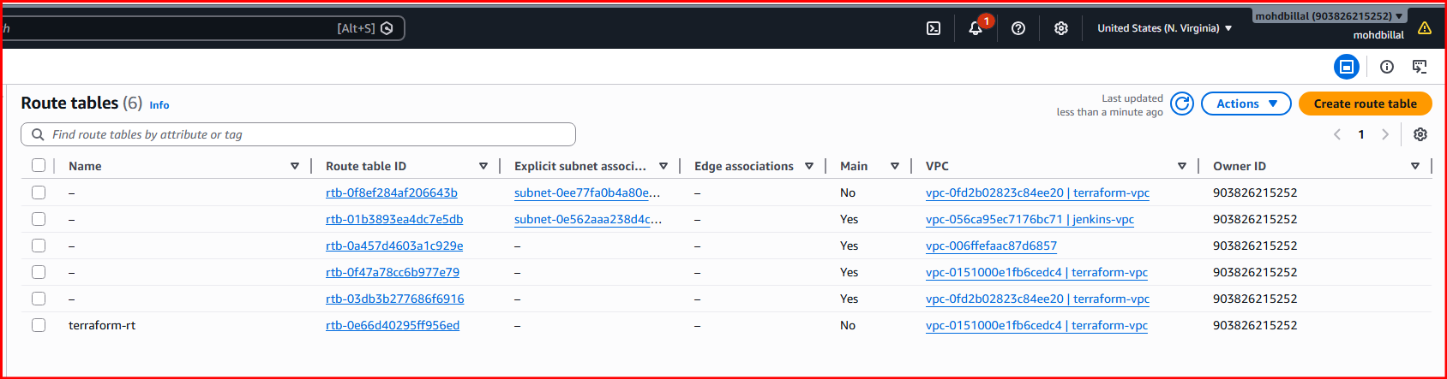
Create Subnet:
Created a public subnet for the vpc
Syntax:
resource "aws_subnet" "terraform_subnet" {
vpc_id = aws_vpc.terraform_vpc.id
cidr_block = "10.0.1.0/24"

tags = {
Name = "terraform-subnet"
}
}
Execute terraform init and apply commands

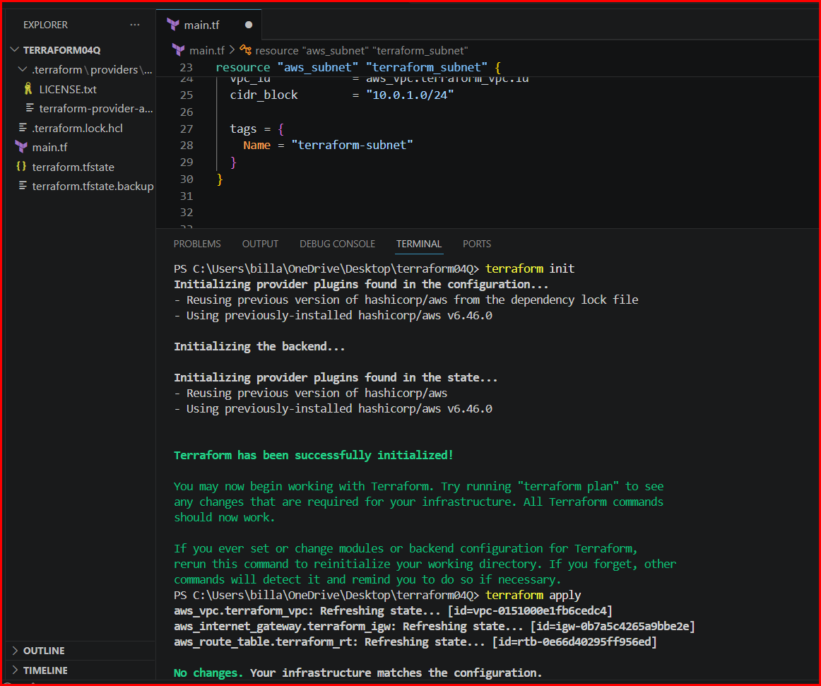
Subnet has been created successfully validated in aws portal

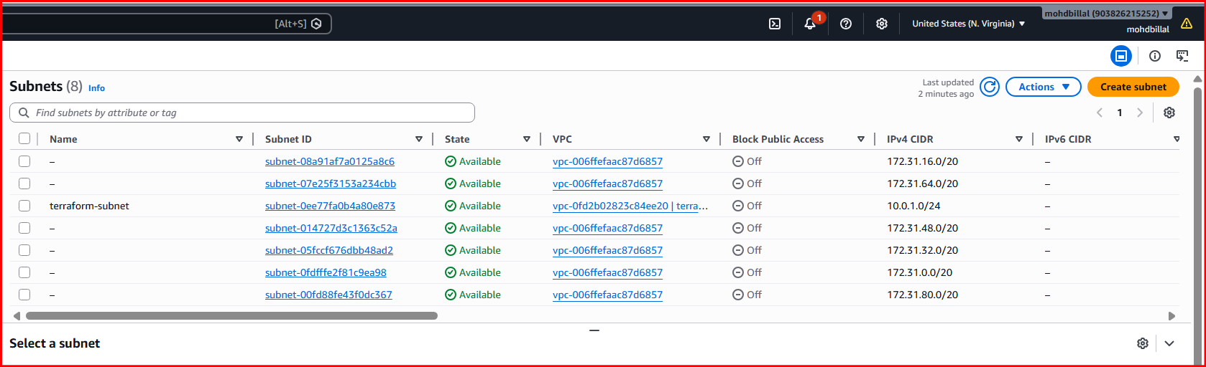
Associate subnet with Route Table:
Created subnet and route table and we need to associate them
Syntax:
resource "aws_route_table_association" "terraform_rta" {
subnet_id = aws_subnet.terraform_subnet.id
route_table_id = aws_route_table.terraform_rt.id
}

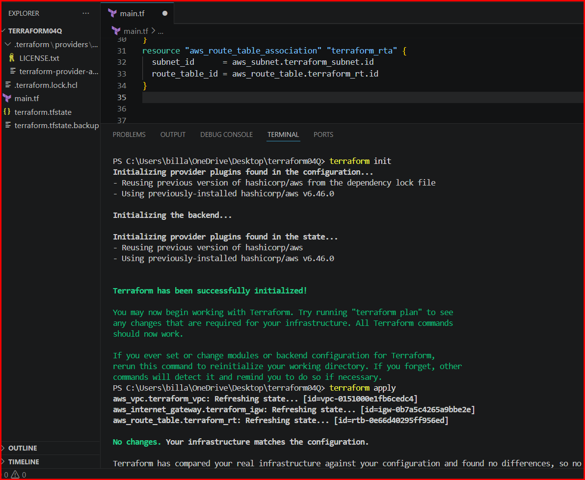

Route table association has been done.
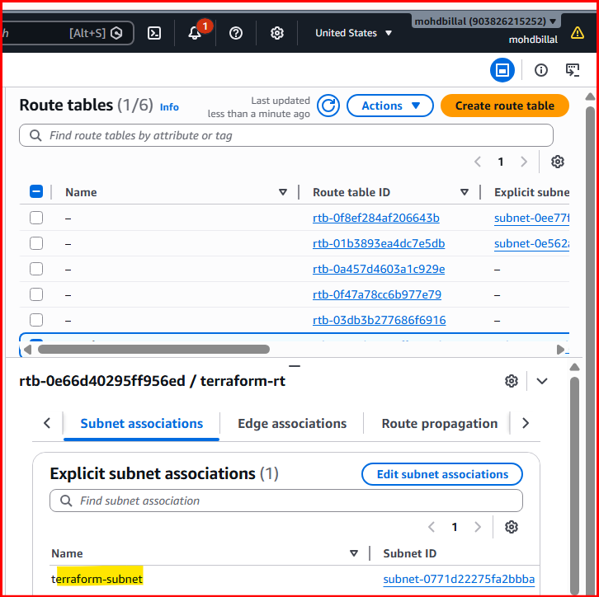
Create Security Group to allow port 22.80,443:
Also created a sg and allowed the ports and all traffic from outbound rules using ingress and egress in terraform
Syntax:
resource "aws_security_group" "terraform_sg" {
vpc_id = aws_vpc.terraform_vpc.id
description = "Allow all inbound traffic"
ingress {
from_port = 22
to_port = 22
protocol = "tcp"
cidr_blocks = ["0.0.0.0/0"]
}
ingress {
from_port = 80
to_port = 80
protocol = "tcp"
cidr_blocks = ["0.0.0.0/0"]

}
ingress {
from_port = 443
to_port = 443
protocol = "tcp"
cidr_blocks = ["0.0.0.0/0"]
}
egress {
from_port = 0
to_port = 0
protocol = "-1"
cidr_blocks = ["0.0.0.0/0"]
}

tags = {
Name = "terraform-sg"
}
}
Execute terraform init and apply commands

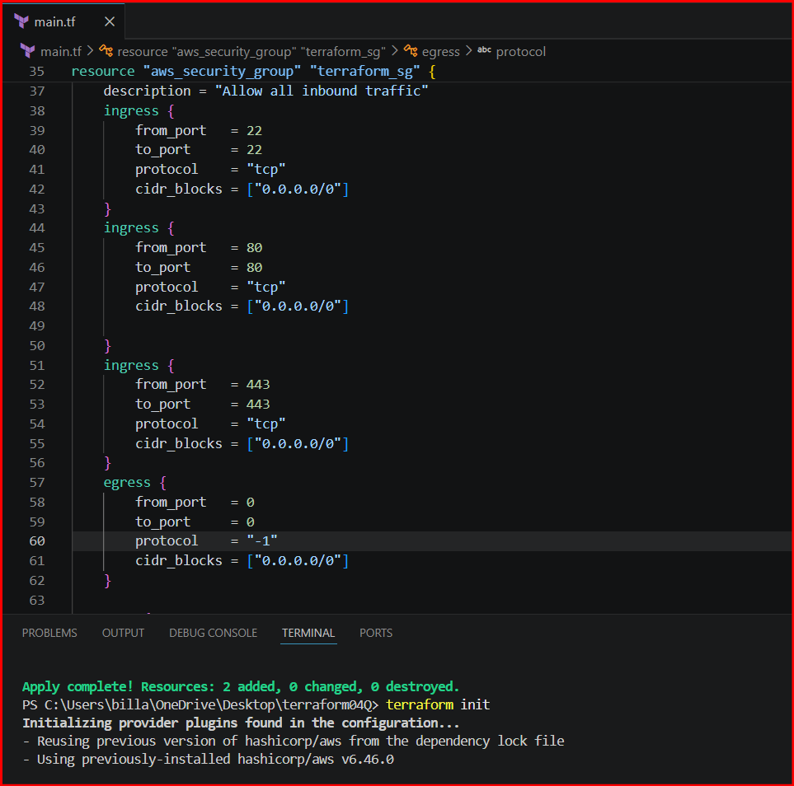

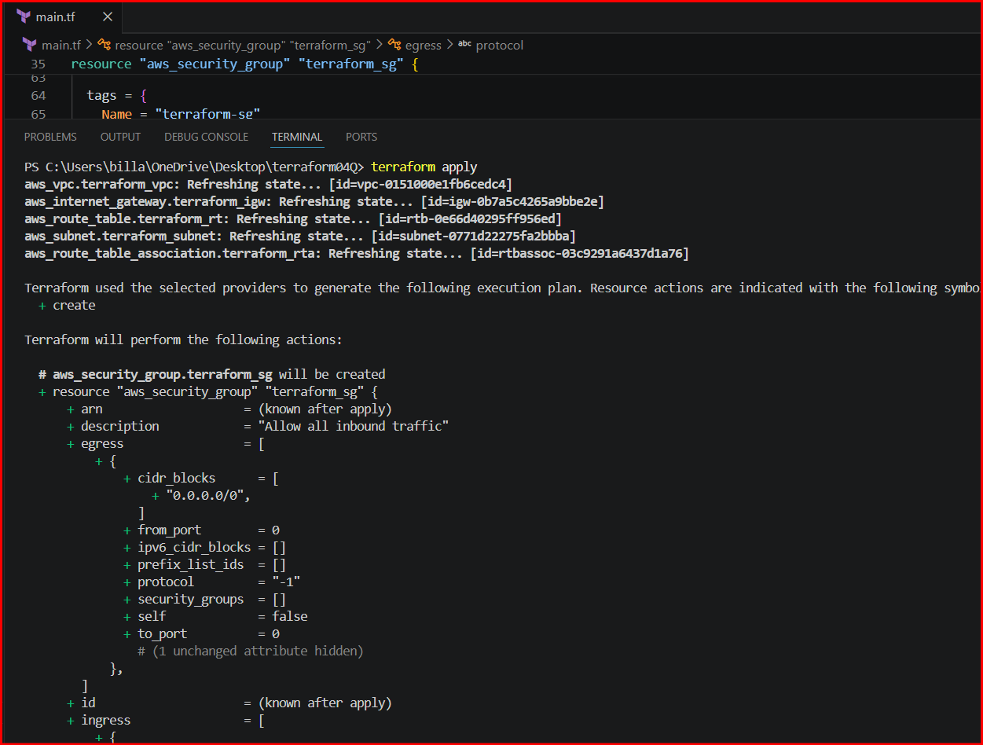
Sg has been created and verified the inbound and outbound rules in aws

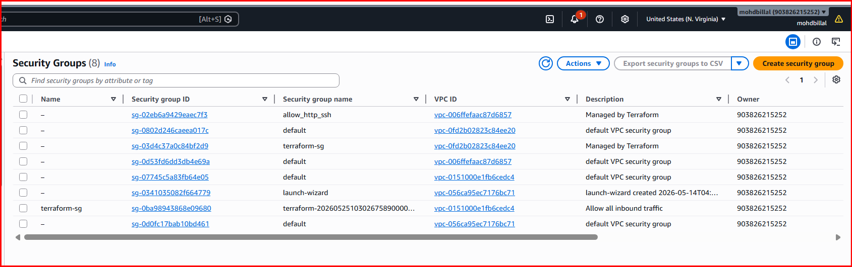

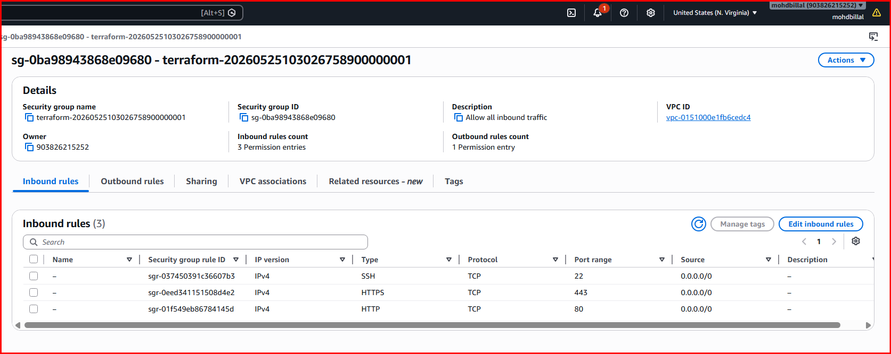

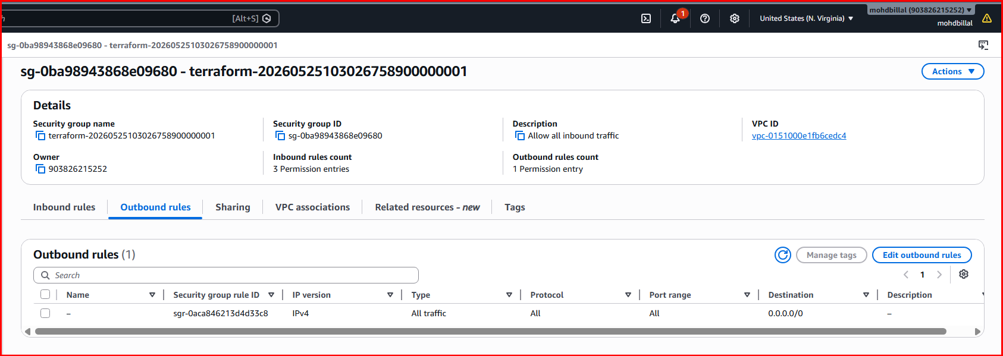
Create a network interface with an ip in the subnet that was created in step 4:::
Need to create a network interface and need to allocate to ec2
A network interface is assigned an IP address either automatically or manually based on its subnet.
Syntax:
resource "aws_network_interface" "terraform_eni" {
subnet_id = aws_subnet.terraform_subnet.id
security_groups = [aws_security_group.terraform_sg.id]

tags = {
Name = "terraform-eni"
}
}
Execute init and apply commands

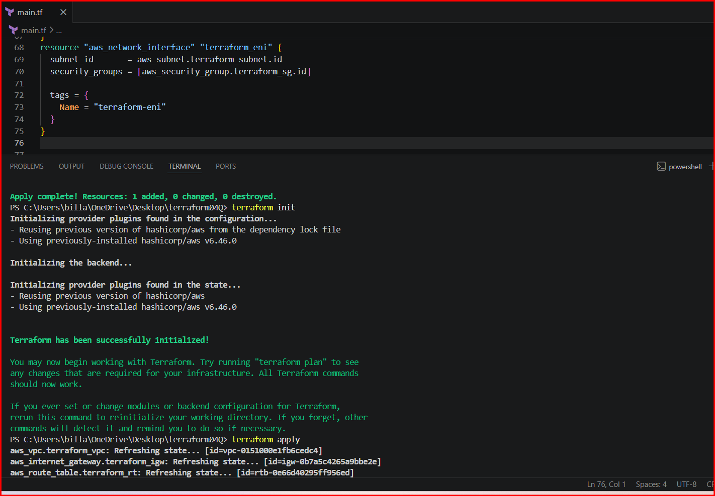
Network interface has been created

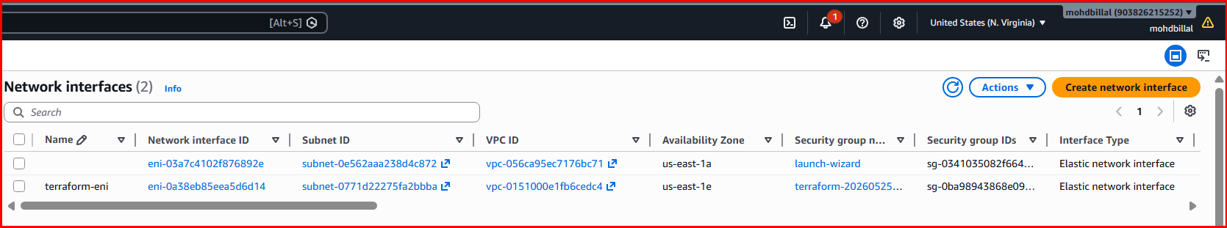
Assign an elastic IP to the network interface created in step 7::
Creating an elastic ip and using to ec2 instance
Syntax:
resource "aws_eip" "terraform_eip" {
domain = "vpc"
network_interface = aws_network_interface.terraform_eni.id
tags = {
Name = "terraform-eip"
}
}
EIP has been allocated

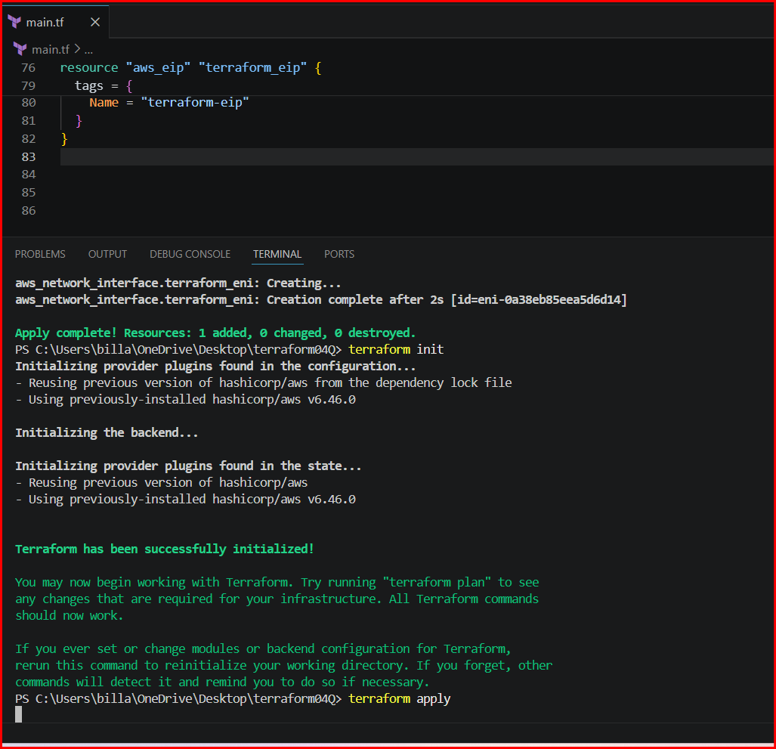
verifying

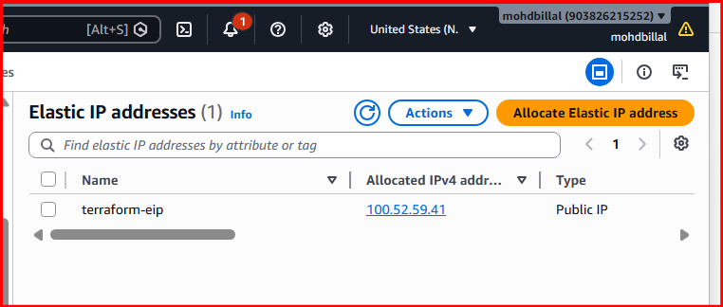
Create Ubuntu server and install/enable apache2::
Add a resource block for instance launching and install apache 2 using userdata the preferred linux is ubuntu
Syntax:
resource "aws_instance" "terraform_instance" {
ami = "ami-0b6c6ebed2801a5cb"
instance_type = "t3.micro"
network_interface {
network_interface_id = aws_network_interface.terraform_eni.id
device_index = 0
}
tags = {
Name = "terraform-instance"
}
user_data = <<-EOF
#!/bin/bash
apt update -y
apt install -y apache2
systemctl start apache2
systemctl enable apache2
EOF
}
output "network_interface_id" {
value = aws_network_interface.terraform_eni.id
}
output "instance_public_ip" {
value = aws_eip.terraform_eip.public_ip
}

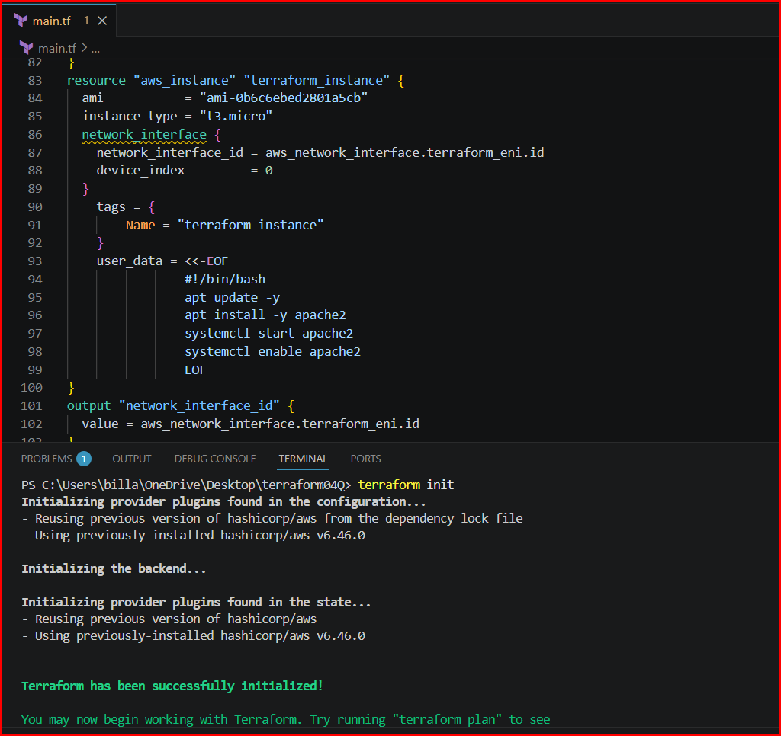

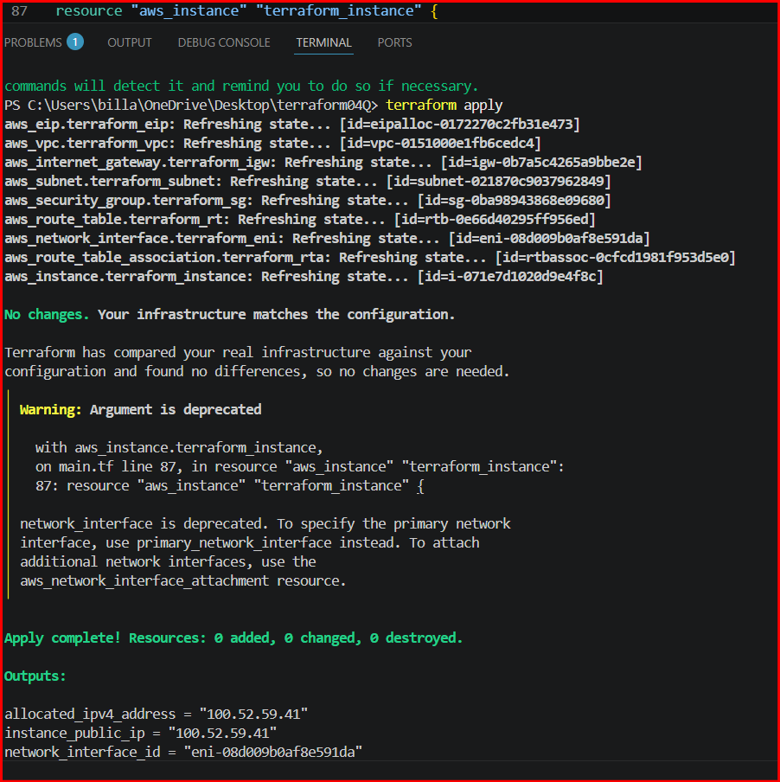
Instance has been successfully created

Issues faced:
But iam unable to connect to website because I didn’t attached igw to route tables so that the userdata package is not installed and im unable to connect so that I attached again using the below syntax and applied again and im able to get the page
Syntax:
resource "aws_route_table" "terraform_rt" {
vpc_id = aws_vpc.terraform_vpc.id

tags = {
Name = "terraform-rt"
}
route {
cidr_block = "0.0.0.0/0"
gateway_id = aws_internet_gateway.terraform_igw.id
}
}

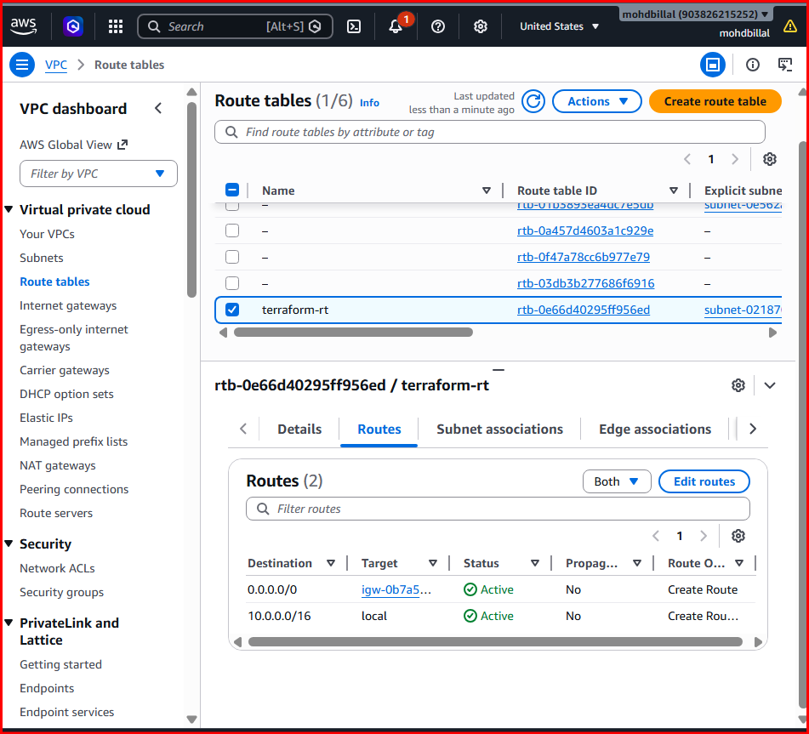
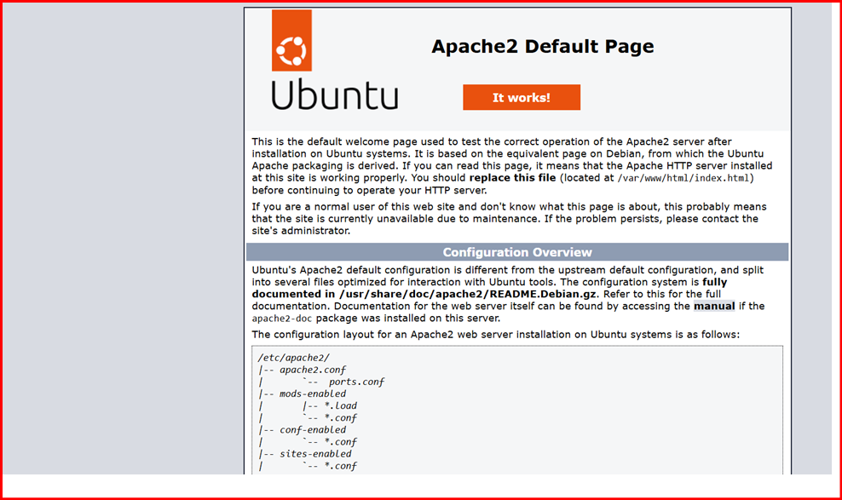

Final Task Syntax::
resource "aws_vpc" "terraform_vpc" {
cidr_block = "10.0.0.0/16"

tags = {
Name = "terraform-vpc"
}
}

resource "aws_internet_gateway" "terraform_igw" {
vpc_id = aws_vpc.terraform_vpc.id

tags = {
Name = "terraform-igw"
}
}
resource "aws_route_table" "terraform_rt" {
vpc_id = aws_vpc.terraform_vpc.id

tags = {
Name = "terraform-rt"
}
route {
cidr_block = "0.0.0.0/0"
gateway_id = aws_internet_gateway.terraform_igw.id
}
}
resource "aws_subnet" "terraform_subnet" {
vpc_id = aws_vpc.terraform_vpc.id
cidr_block = "10.0.1.0/24"

tags = {
Name = "terraform-subnet"
}
}
resource "aws_route_table_association" "terraform_rta" {
subnet_id = aws_subnet.terraform_subnet.id
route_table_id = aws_route_table.terraform_rt.id
}
resource "aws_security_group" "terraform_sg" {
vpc_id = aws_vpc.terraform_vpc.id
description = "Allow all inbound traffic"
ingress {
from_port = 22
to_port = 22
protocol = "tcp"
cidr_blocks = ["0.0.0.0/0"]
}
ingress {
from_port = 80
to_port = 80
protocol = "tcp"
cidr_blocks = ["0.0.0.0/0"]

}
ingress {
from_port = 443
to_port = 443
protocol = "tcp"
cidr_blocks = ["0.0.0.0/0"]
}
egress {
from_port = 0
to_port = 0
protocol = "-1"
cidr_blocks = ["0.0.0.0/0"]
}

tags = {
Name = "terraform-sg"
}
}
resource "aws_network_interface" "terraform_eni" {
subnet_id = aws_subnet.terraform_subnet.id
security_groups = [aws_security_group.terraform_sg.id]

tags = {
Name = "terraform-eni"
}

}
resource "aws_eip" "terraform_eip" {
domain = "vpc"
network_interface = aws_network_interface.terraform_eni.id
tags = {
Name = "terraform-eip"
}

}
resource "aws_instance" "terraform_instance" {
ami = "ami-0b6c6ebed2801a5cb"
instance_type = "t3.micro"
network_interface {
network_interface_id = aws_network_interface.terraform_eni.id
device_index = 0
}
tags = {
Name = "terraform-instance"
}
user_data = <<-EOF
#!/bin/bash
apt update -y
apt install -y apache2
systemctl start apache2
systemctl enable apache2
EOF
}
output "network_interface_id" {
value = aws_network_interface.terraform_eni.id
}
output "instance_public_ip" {
value = aws_eip.terraform_eip.public_ip
}
output allocated_ipv4_address {
value = aws_eip.terraform_eip.public_ip
}

